OFFICIAL CONGRESSIONAL DISTRICT CONVENTION CALL: To Delegates and Alternates to the Congressional District Six Republican Party of Minnesota.

Pursuant to the constitution of the Republican Party of Minnesota and pursuant to the Official 2015 call for the Republican Party of Minnesota authorized by the Republican Party of Minnesota State Chairman, the Congressional District Six Republican Party is hereby called to convene at:
Elk River High School Zabee Auditorium
900 School Street, Elk River, MN 55330
9:00 AM on Saturday, March 28th, 2015.

The Republican Party Congressional District 6 Convention shall be composed of Delegates and Alternates selected by the 2014 BPOU conventions.

Convention registration is open March 28th from 8:00 AM to 9:30 AM. Convention Registration is $35 for Delegates and Alternates. A $15 fee will be charged to each guest who is not a Delegate or Alternate over the age of 18. Pre-registration is open through March 18th. Online registration is available at www.mncd6gop.com.

The Convention shall be held for the purpose of:
1. Adoption of changes to the Congressional District 6 Constitution
2. Election of Congressional District 6 Officers
3. Transaction of other business as may properly come before the convention

Those seeking a position as a Congressional District 6 party officer should contact: Chairman, Luke Yurczyk at chair@mncd6gop.com or Nominations Committee Chair, Jameson Wakefield at deputychair@mncd6gop.com. Requests to be nominated will not be accepted after March 23, 2015.

Issued at the City of Sartell, State of Minnesota, on the 1st day of March, 2015.

Respectfully,
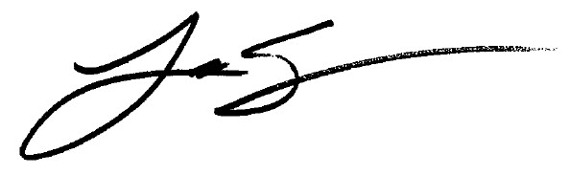
Luke Yurczyk,
Chairman, Congressional District Six Republican Party

NOTE: A quorum is needed to transact any business. Your attendance is extremely important.
-----------------------------------------------------------------------------------------------------------------------------------------------------------------------------------
PRE-REGISTRATION FORM
This form must include a pre-registration fee as indicated below. Please fill out and mail to 13445 Uplander St. NW, Andover, MN 55304 Pre-Registrations must be received by March 18th 2015. Online registration is available at www.mncd6gop.com

NAME:_____________________________________________________ ______________
Delegate or Alternate (please Print – one name per form) BPOU
Please check one: BPOU Delegate_______ or BPOU Alternate______ Number of Guests_______

GUEST NAME(S):____________________________________________________________________________

Please check one: Registration before March 18th: $35______ Guest: $15______ (each) Donation Only: ________

AMOUNT ENCLOSED: $____________ Make Check Payable to: “MNCD6 GOP Federal Committee”

Employer_________________________ Occupation _________________________________ (for campaign finance reporting)

