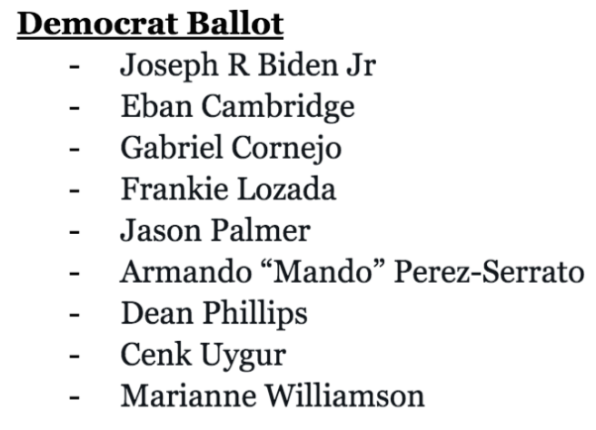
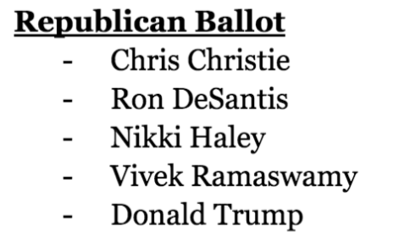

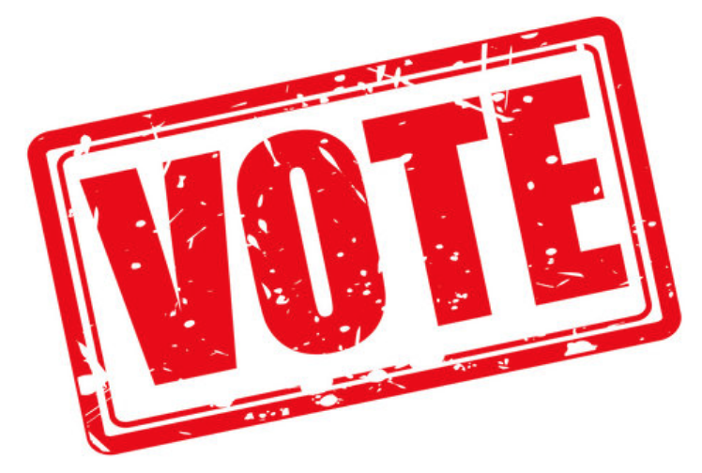

Find your polling place and vote in-person on election day or vote early: https://pollfinder.sos.state.mn.us
Ward ___ Precinct ___:
Vote at ___________________________________________ on election day
Vote at ___________________________________________ early in person

***YOUR BPOU’S DISCLAIMER MUST GO HERE***

VOTE IN MINNESOTA’S
PRESIDENTIAL PRIMARY on MARCH 5th

Find your polling place and vote in-person on election day or vote early: https://pollfinder.sos.state.mn.us

Ward ___ Precinct ___:
Vote at ___________________________________________ on election day
Vote at ___________________________________________ early in person

***YOUR BPOU’S DISCLAIMER MUST GO HERE***

