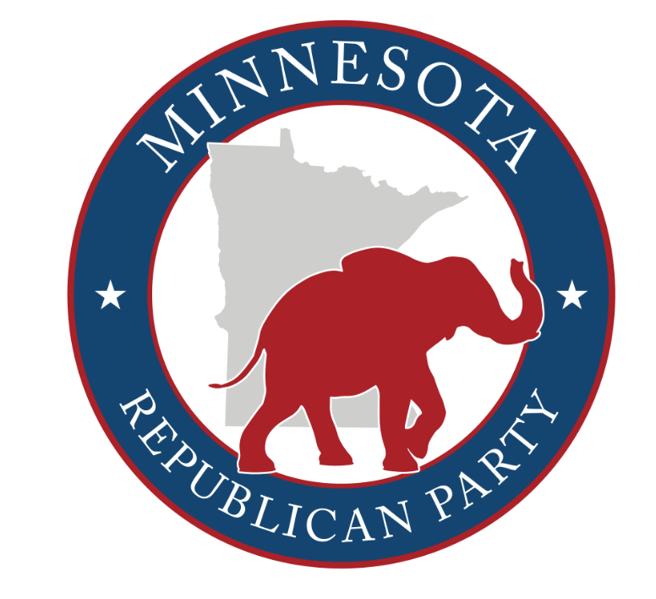

NATIONAL ELECTOR APPLICATION

If you are running to be a national elector within your congressional district, please email your CD to learn more about their application process. Each CD has their own procedures and regulations.

CD 1 - chair@mncd1republicans.org
CD 2 - jditto_mn1@comcast.net
CD 3 - chair@cd3mngop.com
CD 4 - mmmanke@aol.com
CD 5 - beck.alec1961@gmail.com
CD 6 - chair@mncd6gop.com
CD 7 - cab@hutchtel.net
CD 8 - info@mncd8gop.com

If you want to run to be a statewide elector, please complete the application below and email it to the MN GOP’s executive director at AEM@mngop.com with “National Elector Application” in the subject line before Tuesday, April 30th at 11:59 PM. Applications received after 11:59 PM on April 30th will not be accepted. Once your application is received, you will meet with the nominating committee.

Legal first, middle, and last name: ______________________________________________

Address: _______________________________________________________________
Street Unit City State ZIP

BPOU: _____________________________ CD: __________________________

Mobile phone: ____________________________ Email: _________________________

Describe in 300 words or less why you are running to be an elector. Though not required, feel free to attach a resume or references.

(over)
Sign here to certify that if the Republican presidential nominee wins the state of Minnesota in the 2024 general election, and you are required to go to St. Paul to cast a vote on behalf of our Party, you will cast your vote for the winning Republican presidential candidate, not a candidate of your choice:

____________________________________________ ________________________
Signed Dated

Sign here to certify that you understand that this position sometimes comes with media coverage and public scrutiny and that you will conduct yourself in a respectful and appropriate manner at all times so as to reflect the Party and our elected officials and candidates well:

____________________________________________ ________________________
Signed Dated

PAID FOR BY THE REPUBLICAN PARTY OF MINNESOTA. NOT AUTHORIZED BY ANY CANDIDATE OR CANDIDATE’S COMMITTEE. www.mngop.org

